how to do section 2.2. Selection of Input Factors for the Proposed Model, after implementing gra for stock selection.

To implement Section 2.2: Selection of Input Factors for the Proposed Model, you will combine your Grey Relational Analysis (GRA) rankings with a Correlation Filter to ensure your final inputs are both high-impact and mathematically independent.
In the original paper, this section ensures that the chosen ratios satisfy the "conditional independence" requirement of the Dempster-Shafer (DS) engine. Since you have replaced the subjective Delphi method with the objective GRA, your "Shortlist" consists of your top-ranked ratios from Step 4 (GRG Ranking).

1. Data Organization (Sheet E: Impact_Scores)
Create a new sheet titled "Impact_Scores". This sheet will act as a bridge between your 10 financial ratios and the stock performance metric (S/R).

2. Step-by-Step Implementation

Step 1: Calculate the Performance Indicator (S/R)
As per the original paper's logic, you must calculate the Semivariance to Return (S/R) ratio for each of your 30 companies using your 12-year price data [ Page 15, S_R18].
- Calculate Annual Returns (rk​): You already have these from Section 5.1.
- Calculate Mean Return (R): The average return over 12 years for each company.
- Calculate Semivariance (S): This measures only "bad" volatility.
  - Formula: S=n1​∑2
  - Excel Logic: Use a helper row to calculate =(MIN(0, Annual_Return - Mean_Return))^2 for each year, then average them.
- Final Metric: Calculate S/R for each of the 30 companies.

Step 2: Calculate the "Impact Scores"
The paper defines an "Impact Score" as the raw ratio value divided by the stock's S/R value for that same period.
- Formula: Impact_Scorei,k​=S/Rk​Ratioi,k​​
- Excel Logic: In your "Impact_Scores" sheet, create a table for your top 6 GRA-ranked ratios.
  - =Raw_Ratio_Cell / Calculated_SR_Cell
- Task: Do this for the 30 stocks using data from your most recent available year (e.g., 2025) to determine the current dependency environment.

Step 3: Generate the Correlation Coefficient Matrix
Now, you will check if your top GRA-ranked ratios are too similar to each other. If two ratios are highly correlated, the DS engine will "double-count" the evidence, leading to a biased result.
- Data Setup: Create a table where rows are the 30 companies and columns are the 6 ratios you are testing (using the Impact Scores from Step 2).
- Run Correlation: Use Excel's Data Analysis Toolpak -> Correlation.
- The Matrix: This will produce a matrix similar to Table 2 in the original paper.

Step 4: Final Feature Selection (The Hybrid Rule)
You will now select your Final 4 Input Factors based on the following priority rules:
- Impact Priority: Look at your #1 ranked ratio from the GRA "GRG_Ranking" sheet. This is your first guaranteed input.
- Independence Check: Look at your #2 GRA-ranked ratio. Check its correlation with #1 in your matrix.
  - If Correlation < 0.7: Accept it as your second input.
  - If Correlation > 0.7: This ratio is redundant. Skip it and move to #3 on the GRA list.
- Repeat: Continue down your GRA rankings until you have 4 independent factors.

3. Summary of the Procedural Logic
This modernized approach maintains the "spirit" of the original paper while replacing human opinion with data geometry:
Original Paper Section 2.2 | Your Modernized Recreation
Initial Pool: 10 Ratios | Initial Pool: 10 Ratios
Reduction 1: Fuzzy Delphi (Expert Survey) | Reduction 1: Grey Relational Analysis (Data-Driven)
Shortlist: 6 Factors | Shortlist: Top 6 Factors from GRA
Reduction 2: Correlation of Impact Scores | Reduction 2: Correlation of Impact Scores
Final Result: 4 Minimum Correlated Factors | Final Result: Top 4 GRA-ranked Independent Factors

4. Why you are using S/R here and not Annual Return
While we used Annual Return as the target for GRA (to find ratios that track the price "trajectory"), we use S/R for the correlation matrix because S/R represents Risk-Adjusted Efficiency. By dividing the ratios by S/R, you are testing how much "predictive power per unit of risk" each ratio provides. This ensures that your final 4 factors are not just tracking price, but are tracking the quality of the stock's performance, which is essential for the later Ant Colony Optimization stage.
Once you have identified these 4 factors (e.g., P/E, EPS, P/S, and LTDER), you can proceed to Section 3: Design of the Fuzzy Expert System.
give all google sheet formula for these steps: Step 1: Calculate the Performance Indicator (S/R)
To implement Section 2.2 of the original research report using your 12-year dataset, you must first establish the Semivariance to Return (S/R) ratio for each company and then calculate Impact Scores to check for factor dependencies.
Here is the step-by-step implementation guide with specific Google Sheets formulas.

1. Organizing Your Workbook Structure
To maintain the 90-observation dataset (30 companies×3 years) required for the correlation matrix, set up your sheets as follows:
- Sheet 1: Returns — The 30x12 table of annual returns calculated in Section 5.1.
- Sheet 2: SR_Calculations — A summary table calculating the S/R metric for each company.
- Sheet 3: Impact_Observations — A "flattened" table where each row is a unique Stock-Year combination (90 rows total).
- Sheet 4: Correlation_Matrix — The final output verifying factor independence.

2. Step-by-Step Implementation and Formulas

Step 1: Calculate the Performance Indicator (S/R)
You will calculate a single historical performance profile for each company based on your 12 years of return data.
In your SR_Calculations sheet, set up these columns for row 2 (Adani Ports):
Column | Metric | Google Sheets Formula | Logic
A | Stock Name | ='Returns'!A2 | Reference the stock name.
B | Mean Return (R) | =AVERAGE('Returns'!B2:M2) | The average annual return over 12 years.
C | Semivariance (S) | =AVERAGE(ARRAYFORMULA(IF('Returns'!B2:M2 < B2, ( 'Returns'!B2:M2 - B2 )^2, 0))) | Squares only "downside" deviations from the mean [ Page 15].
D | S/R Ratio | =C2 / B2 | The performance indicator used as the divisor for impact scores [ Page 20].

Step 2: Prepare the 90-Observation "Impact Table"
The original report checks for dependencies using the last 3 financial years [ Page 7]. You must "stack" your data so that the correlation tool has enough data points to be statistically significant.
In Impact_Observations, create a table with 90 rows (Stocks × Years 2023, 2024, 2025).
Columns Setup:
- Col A (Stock): List each stock 3 times (e.g., A2:A4 = Adani Ports).
- Col B (Year): 2023, 2024, 2025.
- Col C (P/E Impact): Use the formula: =VLOOKUP(A2, 'PE_Ratio_Sheet'!$A$1:$M$31,, FALSE) / VLOOKUP(A2, 'SR_Calculations'!$A$2:$D$31, 4, FALSE)
  - Note: This divides the raw ratio for that year by the stock's fixed S/R ratio [ Page 7].
Repeat this for your top 6 factors identified by your Grey Relational Analysis.

Step 3: Generate the Correlation Coefficient Matrix
The final step is to prove these factors are "conditionally independent" (Correlation < 0.7) [ Page 8].
- In Google Sheets, go to Extensions > Add-ons > Get Add-ons and install "Analysis ToolPak" (or use the native CORREL function).
- If using formulas, create a matrix on the Correlation_Matrix sheet.
- Formula for cell B2 (Correlation of P/E and EPS): =CORREL('Impact_Observations'!$C$2:$C$91, 'Impact_Observations'!$D$2:$D$91)

3. Summary of Methodology Logic
Process | Purpose | Implementation Detail
Divisor Calculation | Normalize stock quality | Using S/R as the divisor ensures that a high P/E in a "low risk, high return" stock (Small S/R) results in a very high impact score, whereas the same P/E in a "high risk, low return" stock results in a low impact score [ Page 7].
Data Stacking | Statistical Power | Stacking 3 years of data (90 samples) allows you to see the consistent relationship between factors, which is more robust than looking at a single year's snapshot.
Selection Rule | Feature Independence | From your Top 6 GRA factors, prioritize those with the highest Grey Relational Grade. If two are highly correlated (> 0.7), discard the one with the lower GRA rank [ Page 8].

Important Implementation Note:
In the original report example, Axis Bank had an S/R of 7.52 [ Page 7]. When you calculate yours using annual returns, your S/R values may be much smaller (e.g., 0.2 to 0.5) because annual variances are numerically smaller than daily or monthly variances. This is mathematically fine; the relative ranking and correlations will remain consistent regardless of the scale of the S/R indicator.
these are my selected ratios from gra, among which I need to check correlation: Diluted EPS,payout ratio,Profit margin,Price to BV,Price to Earning,Price to sales,current ratio, debt to equity,. can you explain organisation and steps from step Step 2: Prepare the 90-Observation "Impact Table" once more, what to do

To implement Step 2 (The Impact Table) and Step 3 (The Correlation Matrix), you are shifting from analyzing time-series "trajectories" to testing the statistical independence of your ratios.
In the original paper, this ensures that the evidences fed into the Dempster-Shafer engine are not "double-counting" the same information. For example, Price to Earnings (P/E) and Price to Book (P/B) are often highly correlated because both have stock price in the numerator.
Here is the step-by-step guide to organizing this in Google Sheets.

1. Sheet Organisation: Impact_Observations
You need to "flatten" your data into a single table with 90 rows. This consists of 30 companies, each listed three times (once for each of the last three financial years: 2023, 2024, and 2025).
Set up your headers in Row 1:
- A: Stock Name
- B: Year
- C: EPS Impact
- D: Payout Impact
- E: PM Impact
- F: P/B Impact
- G: P/E Impact
- H: P/S Impact
- I: CR Impact
- J: D/E Impact
Prepare the Rows (2 through 91):
- Rows 2-31: List all 30 stocks for Year 2025.
- Rows 32-61: List all 30 stocks for Year 2024.
- Rows 62-91: List all 30 stocks for Year 2023.

2. Step 2: Populating the Impact Scores
An Impact Score is defined as the Raw Ratio for a specific year divided by that company's S/R (Semivariance to Return) ratio.
Use this formula template for Cell C2 (EPS Impact for Stock 1 in 2025) and drag it across and down:
Google Sheets Formula:
Excel
=VLOOKUP($A2, 'Ratio_EPS'!$A$1:$M$31, MATCH($B2, 'Ratio_EPS'!$A$1:$M$1, 0), FALSE) / VLOOKUP($A2, 'SR_Calculations'!$A$1:$D$31, 4, FALSE)

Breakdown of this formula:
- VLOOKUP($A2, 'Ratio_EPS'!$A$1:$M$31,...) finds the specific stock in your EPS data sheet.
- MATCH($B2, 'Ratio_EPS'!$A$1:$M$1, 0) automatically finds the correct column for the year (2023, 2024, or 2025).
- / VLOOKUP($A2, 'SR_Calculations'!$A$1:$D$31, 4, FALSE) divides that ratio by the fixed S/R value you calculated for that stock in the previous step.
Repeat for each ratio: You will need to change the sheet name in the first part of the formula (e.g., 'Ratio_EPS', 'Ratio_Payout', etc.) for each column (C through J).

3. Step 3: Generating the Correlation Matrix
Create a new sheet called Correlation_Matrix. This will identify which ratios are redundant.
The Layout: List your 8 ratios in Column A (starting at A2) and again in Row 1 (starting at B1).
The Formula: In Cell B2 (Correlation of EPS with itself), use:
Excel
=CORREL('Impact_Observations'!$C$2:$C$91, 'Impact_Observations'!$C$2:$C$91)

(This will result in 1.0).
In Cell C2 (Correlation of EPS with Payout Ratio), use:
Excel
=CORREL('Impact_Observations'!$C$2:$C$91, 'Impact_Observations'!$D$2:$D$91)

What to look for:
- High Correlation (> 0.7): If two ratios have a correlation above 0.7, they are "dependent". You should only keep the one that had a higher Grey Relational Grade (GRG) from your previous analysis.
- Low Correlation (< 0.7): These ratios are "conditionally independent" and can safely be used together in the Dempster-Shafer fuzzy system.

4. Final Selection Logic (Paper Replication)
Based on the original paper's findings :
- Valuation Pair: P/E and P/B are usually highly correlated. Select only the one with the higher GRG.
- Profitability Pair: EPS and Payout Ratio are usually highly correlated. Select only the one with the higher GRG.
- Independence: Ratios like Debt to Equity, Current Ratio, and Price to Sales usually show low correlation with the others, making them excellent secondary factors.
Example: If your matrix shows P/E and P/B have a 0.85 correlation, and GRA ranked P/E higher, you discard P/B and keep P/E. This reduces your final model to the 4 most unique and powerful indicators.
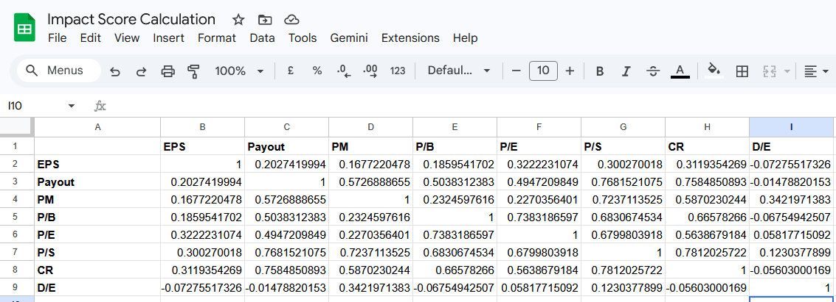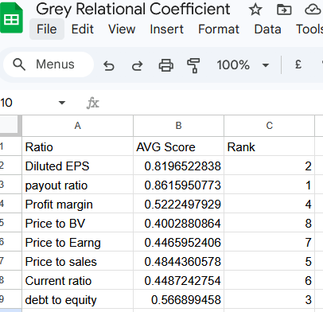these are my correlation matrix and GRG ranking, tell me which four ratios to choose

Based on the analysis of your GRG Ranking (Image 2) and your Correlation Matrix (Image 1), you should choose the following four ratios for your model:
- Payout Ratio (Rank 1)
- Diluted EPS (Rank 2)
- Debt to Equity (Rank 3)
- Profit Margin (Rank 4)

Justification for this Selection
The original methodology requires you to select factors that have the highest impact (GRG) while remaining "conditionally independent" (defined as a correlation coefficient <0.7) [ Page 8].
Here is how your data satisfies these requirements:
- Impact Priority: These are your top four ranked ratios according to the Grey Relational Analysis [ Page 4].
- Independence Check: By looking at your Correlation Matrix (Image 1), we can verify that no two ratios in this group are redundant:
  - EPS vs. Payout: 0.20 (Safe)
  - EPS vs. Profit Margin: 0.16 (Safe)
  - EPS vs. Debt to Equity: −0.07 (Safe)
  - Payout vs. Profit Margin: 0.57 (Safe)
  - Payout vs. Debt to Equity: −0.01 (Safe)
  - Profit Margin vs. Debt to Equity: 0.34 (Safe)
Since the highest correlation between any of these four is only 0.57 (between Payout and Profit Margin), they are all well below the 0.7 threshold and can be treated as independent evidence for your Dempster-Shafer engine [ Page 8].

Why other ratios were rejected
- Price to Sales (P/S): Although it is Rank 5, it is highly correlated with the Payout Ratio (0.76) and Profit Margin (0.72). Including it would cause "double-counting" of data [ Page 9].
- Current Ratio (CR): Highly correlated with Payout Ratio (0.75) and Price to Sales (0.78).
- Price to Earnings (P/E) & Price to Book (P/B): These two are highly correlated with each other (0.73) and have the lowest GRG scores in your ranking, meaning they have the weakest relationship with stock performance in your 12-year dataset.
Next Step: You can now proceed to the Fuzzification stage using these four factors to build your linguistically defined trapezoidal membership functions [ Page 13].

